QUESS CORP LIMIITED

HEAD OFFICE - 3/3/2,QUESS TOWER, SKY WALK AVENUE, 32/4, SERVICE ROAD, MUNESWARANAGAR, ROOPENA AGRAHARA, BOMMANAHALLI, BENGALURU, KARNATAKA,

WINNING TOGETHER

 | 2002963686 |  | 5220933085
 | AUTI SHUBHAM ANAND |  | 30.00
DATE OF JOINING | 13/03/2024 |  | 30.00
DESIGNATION | LOGISTICS EXECUTIVE |  | HDFC BANK
DEPUTED AT | REXEL INDIA PRIVATE LIMIT ED | BANK A/C NO | 1987104000067306
 |  | INSURANCE NO | BLR-NC-Q0091-001-0019305-A
 |  | LOCATION
 | PY KRP00139920000513638 |  | GS10141493
 | 102052109130  DRBPA9190Q |  | 0.00

BASIC  HOUSE RENT ALLOWANCE | 7,517.00 | PROVIDENT FUND  PROFESSIONAL TAX | 20000
OTHER ALLOWANCE  STATUTORY_BONUS | 3,531.00

BASIC |  |  |  | ACCOMODATION
HOUSE RENT ALLOWANCE | 62185 | 30068 | 92253
OTHER ALLOWANCE | 33015 |  | 471 39 | OTHER
STATUTORY_BONUS | 9460 |  |  | PREVIOUS EMPLOYER | INCOIvIE

DEDUCTION U/S 16 (PROFESSIONAL TAX) DEDUCTION U/S 16(IA) (STANDARD DEDUCTION) DEDUCTION UNDER CHAPTER VI-A DEDUCTIONS U/S (10) AND (17) DEDUCTIONS UNDER CHAPTER VI (SEC 80)
EDUCATION CESS
75000 SECTION 87 RELIEF

TAX ON INCOME
TAX ON INCOME BLESS 87 RELIEF]
TAX RECOVERED
TAXABLE INCOME (NET SALARY - DEDUCTIONS)

NOTE: THIS IS A COMPUTER GENERATED DOCUMENT DOES NOT REQUIRE ANY SIGNATURE

FOR ANY OUERY, PLEASE REACH US @ 1800-572-3333 OR WRITE TO HELP@QUESSCORP.COM

248664

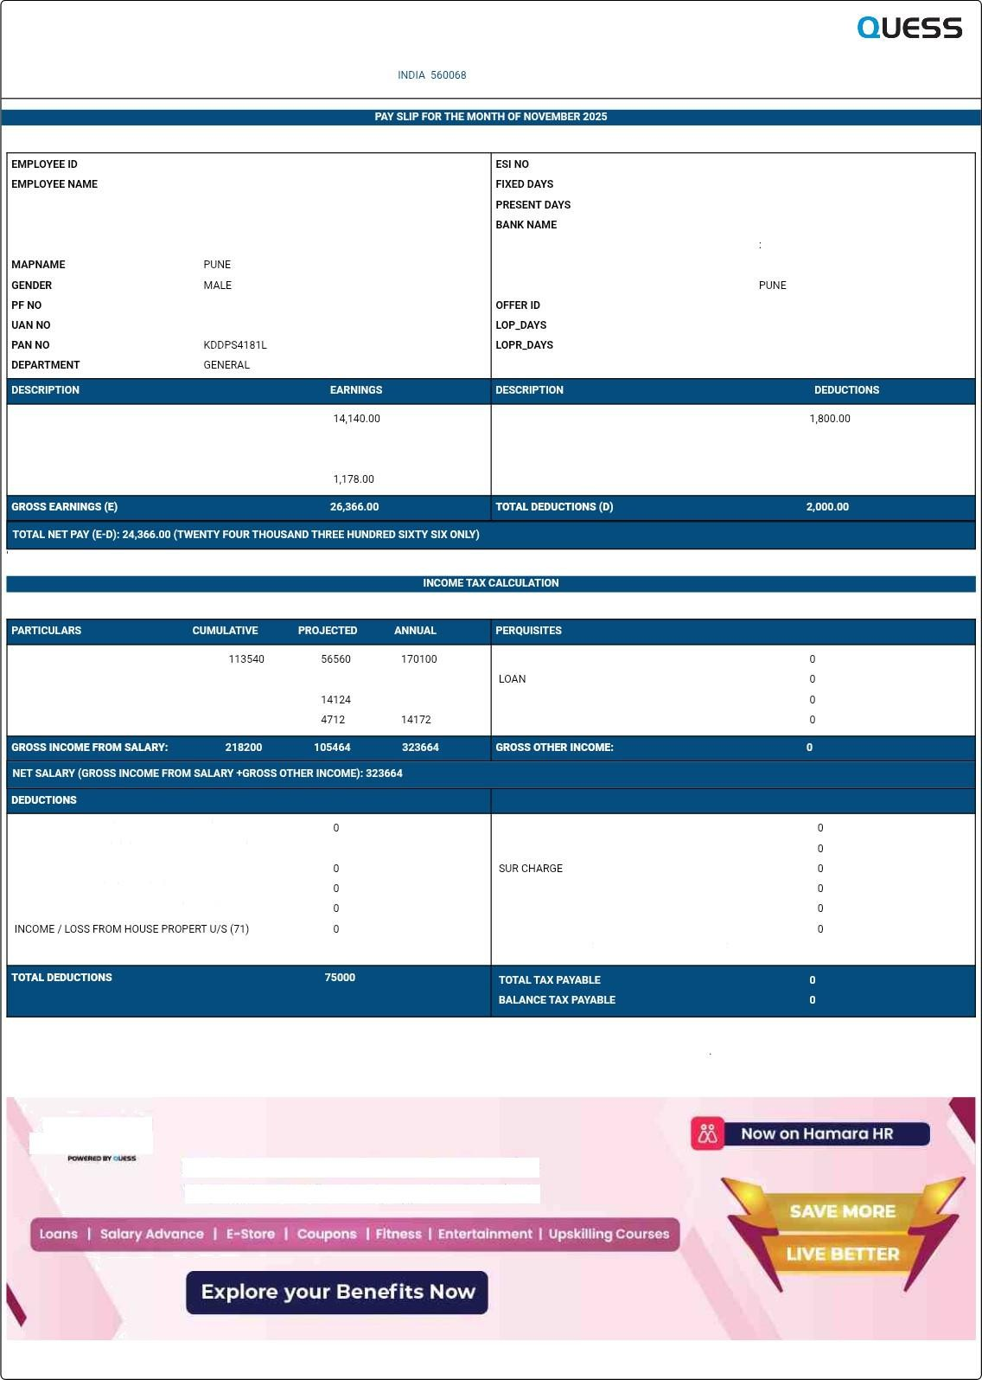

101929236802

Quess introduces Homoro Benefits
Employee Benefits & Engagement Platform

FEB 3 2026 10:T3AM

